MACHINE LEARNING

1. Underfitting (High Bias)
The Analogy: A student who barely opens the textbook. They only study the titles of the chapters and memorize a single generic rule (like "The answer is always C"). When they take the practice test, they fail. When they take the real exam, they fail.
In Machine Learning: Underfitting happens when your model is too simple to learn the underlying patterns in your data.
- Why it happens: You tried to fit a completely straight line (Linear Regression) through data that is clearly curved, or you didn't give the model enough features to learn from.
- The Result: The model performs poorly on your training data and poorly on new, unseen data.
- Also known as: High Bias (The model has a strong, rigid bias about what the data should look like, ignoring what the data actually tells it).
2. Overfitting (High Variance)
The Analogy: A student who aggressively memorizes every single word of the practice exam, including the random typos, page numbers, and exact order of the questions. When they retake the practice exam, they get a perfect 100%. But when they sit down for the actual exam—where the questions are slightly rephrased—they completely panic and fail because they didn't learn the concepts, they just memorized the exact examples.
In Machine Learning: Overfitting happens when your model is too complex and fits your data too perfectly. It doesn't just learn the trend; it learns the random noise, mistakes, and quirks specific to that exact dataset.
- Why it happens: Your model has too many parameters (e.g., a massive polynomial equation like $y = w_1x + w_2x^2 + w_3x^3 + w_4x^4...$) or you let it train for way too long on a very small dataset.
- The Result: The model looks incredibly accurate on your training data (close to 0% error), but when you feed it new, unseen data, its predictions are wildly wrong.
- Also known as: High Variance (The model's predictions change drastically based on tiny differences in the input data).

Part 1: Evaluating Classification (Logistic Regression)
- When you are dealing with categorical outcomes (like identifying if an email is Spam (1) or Not Spam (0)), you don't evaluate by calculating "how far off" the numbers are. Instead, you look at counts of right vs. wrong decisions.
1. Train / Test Split (The Golden Rule)
- Before you look at any formulas, remember that you should never evaluate a model on the same data it used to learn.
- You hide a portion of your data (usually 20%) in a "vault"—this is your Test Set.
- You let the model learn from the remaining 80% (Train Set).
- You evaluate the model by seeing how it performs on the unseen Test Set. If it scores 99% on training but 50% on testing, you immediately know your model is overfitting.

Regularization is like a "simplification tax" that we impose on the model. It allows the model to look at all your features but penalizes it if it tries to rely too heavily or wildly on any of them.
The Analogy: The Over-Dramatizing Detective
Imagine a detective trying to solve a case based on a few clues.
- Without Regularization: The detective creates a wildly complex conspiracy theory. They say, "Because the suspect wore a blue hat, had a coffee receipt from 8:04 AM, and sneezed twice, they are 100% the culprit!" This theory works perfectly for this specific suspect, but it completely falls apart on the next case because it's too specific.
- With Regularization: A supervisor steps in and says, "Keep it simple. For every complex detail you add to your theory, I'm going to dock your pay." Now, the detective is forced to focus only on the clues that actually matter (like fingerprints or DNA) and ignore the random background noise (like the color of the hat).
Topic: Bias
When data scientists talk about a model having "high bias," they aren't talking about the parameter ‘b’. They are talking about a model that is underfitting.
- In Plain English: Bias is the error that happens when your algorithm makes assumptions that are way too simple for the actual data. A "highly biased" model has a closed mind—it has already decided what the pattern looks like and refuses to learn from the true complexity of your dataset.
- The Analogy: Imagine your data has a beautiful, complex, wavy pattern. A highly biased algorithm says, "I only look at the world through straight lines." It draws a rigid, straight line right through your curves. Because it made an oversimplified assumption, it misses the target completely.
The Bias-Variance Trade off (The Ultimate Balancing Act)
You will always hear "Bias" paired with its sibling, "Variance":
- High Bias (Underfitting): The model is too simple. It performs poorly on your training data and poorly on new data. (e.g., trying to fit a complex curve with a simple straight line).
- High Variance (Overfitting): The model is too complex. It memorizes the training data perfectly but fails completely on new data because it gets distracted by random noise.
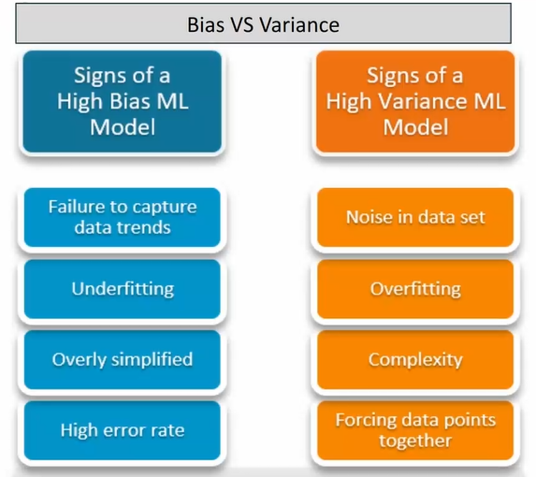
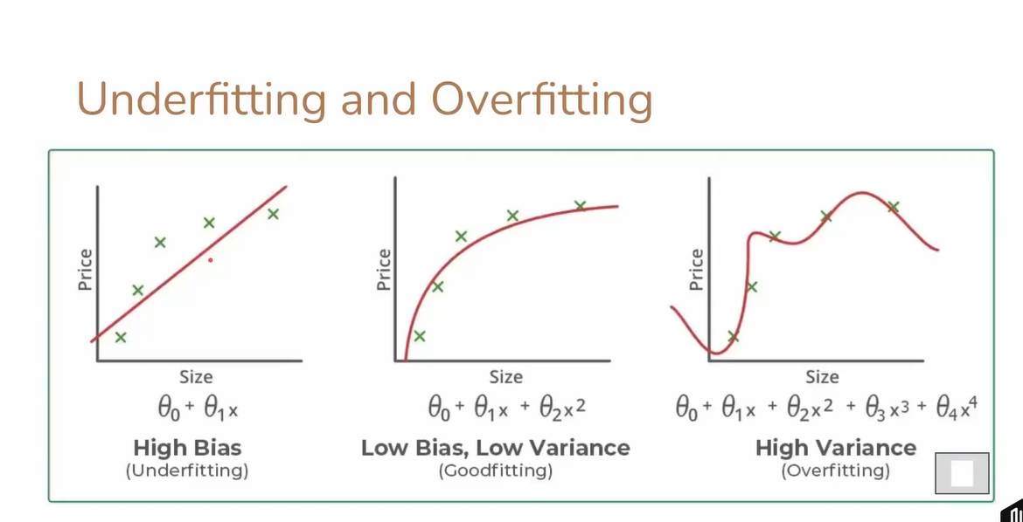

Topic: Error Analysis
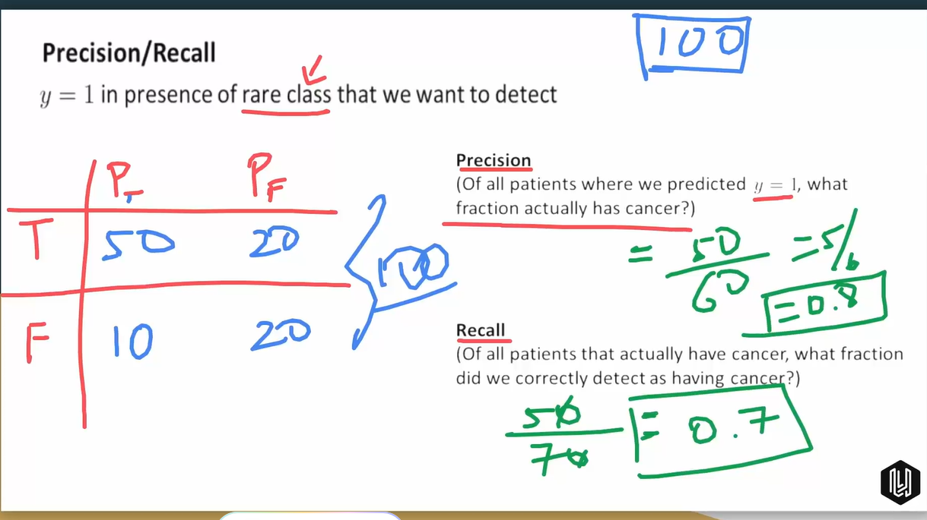

NEURAL NETWORK
A neural network is a collection of tiny mathematical processing units called neurons (or nodes) layered together.
Think of a neural network like a large corporate company making a big decision. You have entry-level employees, managers, and a CEO:
- The Input Layer (The Entry-Level Employees): This is where your data enters the network. If you are predicting house prices, this layer takes in features like square footage, number of bedrooms, and neighborhood quality. If it's an image, this layer takes in the individual pixels.
- The Hidden Layers (The Managers): This is where the magic happens. A network can have one or many hidden layers (which is why it's called Deep Learning). These layers look at the inputs, combine them in different ways, and look for abstract patterns.
  - Example: In facial recognition, the first hidden layer might just look for simple edges or lines. The next layer combines those lines to look for shapes (like circles or squares). The next layer combines those shapes to look for facial features (like eyes, a nose, or a mouth).
- The Output Layer (The CEO): This layer makes the final decision. It hands you the final prediction, like a continuous number (e.g., house price = $350,000) or a probability (e.g., "There is a 98% chance this image is a cat").
🛠️ How it Works: Connecting What You Already Know
Here is the coolest secret in machine learning: A single neuron in a neural network is essentially just a logistic regression model!
Let's trace how information moves through a single neuron:
- Step 1 (Linear Regression part): The neuron takes all its inputs, multiplies them by their individual weights ($w$), and adds a bias ($b$). This gives it a baseline score.
$$\text{Score} = (x_1 \cdot w_1) + (x_2 \cdot w_2) + b$$
- Step 2 (The Activation Function): Instead of just passing that score along as a straight line, the neuron passes it through an activation function. This function squashes or bends the score. (Just like the Sigmoid function you learned about in logistic regression!). This "bending" is what allows the network to learn complex, curvy shapes instead of just rigid straight lines.
- Step 3: The output of this neuron becomes the input for the next layer's neurons.
By stacking hundreds or thousands of these tiny regression models together, the network can learn almost any pattern imaginable.


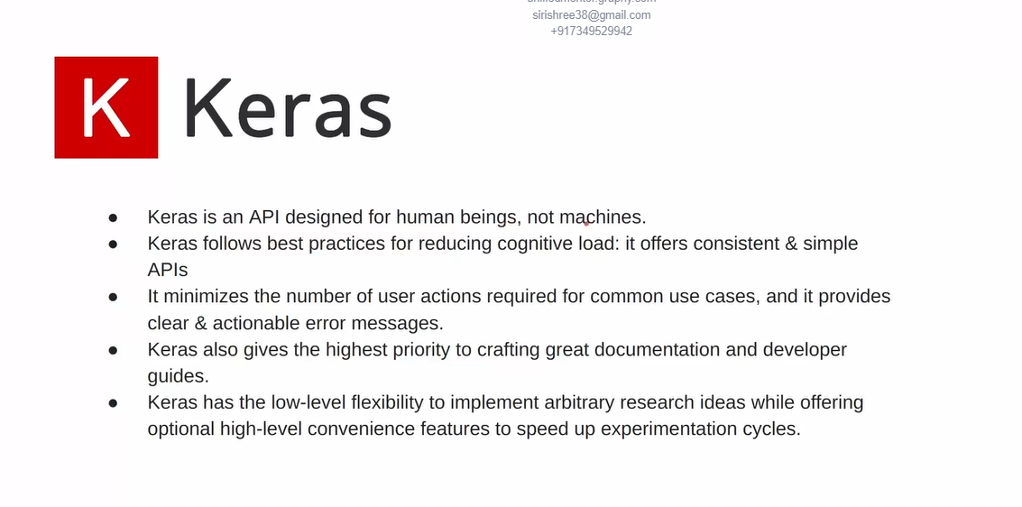
The basic building blocks of tensorflow:
1. Defining the Model (Sequential)
A neural network is a sequence of layers. In TensorFlow, you define this using tf.keras.Sequential. It tells the library: "Hey, I am going to stack layers on top of each other in a specific order."
2. Adding Layers (Dense)
A regular, fully-connected layer of neurons (where every neuron connects to every neuron in the previous layer) is called a Dense layer.
- You tell it how many neurons you want.
- You tell it what activation function to use (like 'sigmoid', 'relu', or 'linear').
3. Compiling the Model (compile)
Before you can train your network, you have to configure its learning strategy. You must tell TensorFlow two crucial things you learned in your regression modules:
- The Loss Function: How should it calculate its error? (e.g., 'mean_squared_error' for Linear Regression, or 'binary_crossentropy' for Logistic/Classification tasks).
- The Optimizer: This is the specific flavor of Gradient Descent it will use to update the weights (w) and biases (b) to shrink the error. A highly popular, smart optimizer choice is called 'adam'.
4. Training the Model (fit)
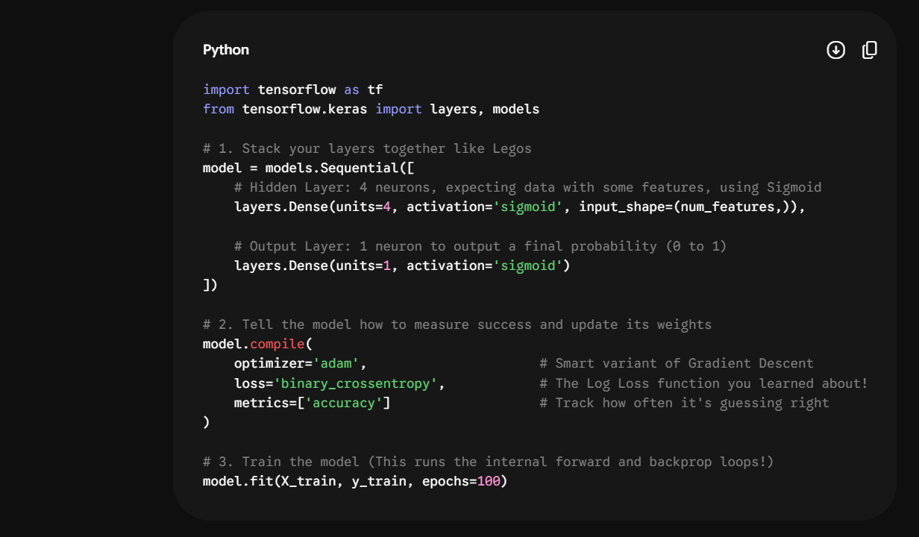
To start the training loop, you call the .fit() function. You hand it your inputs (X), your correct answers (y), and tell it how many epochs (full trips through the dataset) you want it to run. This replaces your manual for i in range(iterations): loops

What does epochs mean?
Imagine you are studying for a massive, difficult final exam, and you have a textbook with 100 practice questions (this is your dataset).
- Reading 1 Question: This is like looking at a single data point.
- Reading all 100 questions once: You have just finished 1 Epoch.
Now, if you only read through those 100 questions exactly one time, are you going to get a perfect score on the exam? Probably not. You might remember a few things, but you haven't mastered the patterns yet.
To actually learn, you need to loop back to the beginning and read the entire book again.
- Going through all 100 questions a second time = Epoch 2.
- Going through all 100 questions a third time = Epoch 3.

Every single epoch consists of two main steps that you have already seen when building models manually:
- Forward Propagation (The Guess): The model looks at every single row in your dataset, calculates the dot products, applies the activation functions, and makes its predictions (y bar). It compares these guesses to the actual answers (y) to find its total error using the loss function.
- Backpropagation (The Correction): The model calculates the gradients and uses its Optimizer (like Gradient Descent or Adam) to update its weights and biases to make the line or curve fit a little bit better.

Here is a beautifully formatted, structured guide on K-Means Clustering that you can directly copy and paste into Microsoft Word or any other text editor.

TOPIC: K-Means Clustering
1. Core Concept: What is Clustering?
Unlike Supervised Learning (such as Linear and Logistic Regression), where data has predefined labels or correct target answers, Clustering belongs to Unsupervised Learning.
- The Goal: Provide an algorithm with unlabeled, raw data and allow it to discover natural groupings, hidden patterns, or structural similarities on its own.
- K-Means Clustering: The most widely used clustering algorithm.
  - "K": A user-defined integer representing the number of clusters (groups) to create.
  - "Means": Refers to calculating the average location (or centroid) of the data points in a cluster.
2. Step-by-Step Algorithm (The Iterative Process)
Step 1: Initialization (Choose Random Leaders)
- Define the value of K (e.g., $K = 3$).
- The algorithm randomly selects $K$ data points or locations across the dataset space. These points act as the initial group centers, mathematically known as Centroids.
Step 2: Assignment (Join the Closest Leader)
- Every single data point in the dataset calculates its geometric distance (typically using Euclidean distance) to all $K$ centroids.
- Each data point is assigned to its nearest centroid, creating $K$ temporary clusters.
Step 3: Update (Move Leaders to the Center)
- The algorithm looks at all the data points assigned to a specific cluster.
- It calculates the mathematical mean (average coordinates) of those points.
- The centroid is then moved from its old location to this new average center point.
Step 4: Repeat Until Convergence
- Because the centroids moved, their distances to data points change.
- The algorithm repeats Step 2 (Assignment) and Step 3 (Update) in a loop.
- Convergence: The process stops automatically when data points stop switching groups and the centroids stop changing position.
3. Real-World Applications
- Customer Segmentation: Grouping e-commerce users based on purchasing traits (e.g., high-spending/rare shoppers vs. low-spending/frequent shoppers) to design tailored marketing campaigns.
- Document and Topic Clustering: Automatically organizing massive volumes of unlabeled text files or articles into distinct categories (e.g., Sports, Tech, Politics) based on word frequencies.
- Image Compression: Evaluating thousands of individual pixel colors in an image, clustering them into a smaller set of dominant colors (e.g., 8 or 16), and replacing similar pixels to minimize overall file sizes.
- Anomaly & Fraud Detection: Clustering standard user or network traffic behaviors together. If a new data point falls completely isolated from any major cluster, it flags it as an outlier or potential exploit.
4. Hyperparameter Optimization: Choosing the Right "K"
Because you must manually set the value of $K$ before running the algorithm, choosing an unoptimized number can result in poor groupings:
- If $K$ is too small (e.g., $K=1$), everything is jammed into one useless group.
- If $K$ is too large (e.g., $K = \text{total number of items}$), every item becomes its own cluster, removing any generalization.
The Elbow Method
To find the ideal number of clusters, data scientists plot a validation metric:
- Run the K-Means algorithm multiple times, incrementing $K$ each time ($K = 1, 2, 3, 4 \dots$).
- For each run, calculate the Inertia (or Within-Cluster Sum of Squares - WCSS), which measures how tightly packed the points are to their respective centroids.
- Plot the values on a line graph where the X-axis is $K$ and the Y-axis is Inertia.
- The Selection Rule: The resulting graph typically resembles a bending arm. The point where the drastic drop in error sharply slows down and begins to flatten out forms an "Elbow". This elbow point indicates the optimal, most efficient value for $K$.

TOPIC – DECISION TREE
1. What is a Decision Tree?
Think of a Decision Tree like a high-tech game of 20 Questions or a flowchart. It starts at a single question, and depending on whether the answer is "Yes" or "No", it branches down to another question, until it finally reaches an answer.
- The Motive: Imagine you want to predict whether a child in your humanitarian project dataset will experience a significant delay in being transferred from CBP to HHS based on features like Daily Intake Volume or Weekend vs. Weekday.
- How it looks:
  - Question 1: Is the daily intake volume greater than 500 kids?
    - Yes $\rightarrow$ Question 2: Is it a weekend?
      - Yes $\rightarrow$ Prediction: High Risk of Delay.
      - No $\rightarrow$ Prediction: Medium Risk of Delay.
    - No $\rightarrow$ Prediction: Low Risk of Delay (Smooth transition).
Key Terms to Keep in Your Notebook:
- Root Node: The very top question where the split begins.
- Decision Nodes: The intermediate questions along the branches.
- Leaf Nodes: The final stops at the very bottom that give you the actual prediction (no more questions).
2. How does a Decision Tree "Learn"?
When you train a neural network, it learns by tweaking weights ($w$) and biases ($b$). A Decision Tree doesn't have weights. Instead, learning means finding the absolute best questions to ask at the right time.
If you give a tree a dataset, how does it know whether to split by "Intake Volume" first or "Weekend vs. Weekday" first? It uses mathematical metrics to find the cleanest, purest split.
- For Classification (Yes/No categories): It uses concepts called Gini Impurity or Entropy (Information Gain).
  - Simple Analogy: Imagine a bucket filled with 50 red marbles and 50 blue marbles. It's totally messy and mixed up (High Impurity). If a question splits them perfectly so one bucket has 50 red and the other has 50 blue, that split is incredibly pure (Low Impurity). The tree always picks the question that creates the purest buckets!
- For Regression (Continuous numbers): It looks at Variance Reduction or Mean Squared Error (MSE), trying to group similar numbers together so their averages make highly accurate predictions.
⚠️ The Fatal Flaw: Overfitting (High Variance)
As you saw in your earlier notes, a model has High Variance when it overcomplicates things and memorizes the training data perfectly, but fails completely on new data.
Decision Trees are notoriously guilty of this. Left to their own devices, they will keep asking questions until every single leaf node has exactly one data point in it. They become so specific to your training data that they become useless for new data.
To fix this, we use Pruning (cutting the tree short by setting a max_depth, like telling the tree: "You are only allowed to ask a maximum of 5 questions").
3. Random Forest: Strength in Numbers
Because a single Decision Tree is prone to getting distracted by random noise (overfitting), data scientists came up with a brilliant idea: What if instead of relying on one giant tree, we build an entire forest of trees and let them vote?
This is called Random Forest, and it relies on an ensemble (teamwork) concept known as Bagging (Bootstrap Aggregating).
How a Random Forest works:
- Bootstrap the Data: If your dataset has 1,000 rows, the algorithm randomly samples rows to create unique, slightly different mini-datasets for each tree.
- Random Features: When building each tree, the algorithm only allows it to look at a random subset of your columns (features). Tree #1 might only be allowed to look at Daily Intake and HHS Care Loads, while Tree #2 looks at Discharge Rates and Dates.
- The Democratic Vote: If you build a forest of 100 trees, you pass a new data point through all 100 trees. If 85 trees predict "Delay" and 15 predict "No Delay", the final output of the Random Forest is Delay.
Why it’s awesome: By forcing the trees to be different (random data + random features), they don't all make the same mistakes. The high variance of individual trees cancels out, giving you a highly stable, incredibly accurate model that is very hard to overfit.
4. Gradient Boosting & XGBoost: Learning from Mistakes
While Random Forests build trees independently side-by-side, Gradient Boosting builds trees sequentially—one after the other, like a chain reaction.
Instead of letting trees vote democratically, each new tree is explicitly trained to fix the mistakes made by the previous tree.
The Step-by-Step Chain Reaction:
- Tree #1 (The Baseline): It makes a rough, simple guess on your dataset. It gets some things right, but makes a lot of errors (called Residuals).
- Tree #2 (The Corrector): Instead of trying to predict the final target, Tree #2 is trained specifically to predict the errors of Tree #1.
- Tree #3 (The Fine-Tuner): It is trained to predict the leftover errors of Tree #2.
This process repeats hundreds of times. By adding up the predictions of all these corrected steps, you get an extraordinarily precise model.
What is XGBoost?
XGBoost stands for eXtreme Gradient Boosting. It is fundamentally the same concept as Gradient Boosting, but it is engineered to be a Formula 1 race car.
- It was built by data scientists to optimize hardware speed (utilizing CPU cores and parallel processing flawlessly).
- It has built-in Regularization (which, as you remember, prevents overfitting by penalizing overly complex paths).
- It handles missing data values automatically.
- It is so fast and accurate that for years, it has been the go-to algorithm to win global machine learning competitions (like Kaggle) on tabular/spreadsheet data.
Summary Checklist for Your Notebook
Algorithm | How it works | Pro | Con
Decision Tree | A single flowchart of yes/no questions. | Extremely easy to see exactly how it made a choice. | Overfits easily; highly unstable if data changes slightly.
Random Forest | Outpoints noise by letting a crowd of independent, random trees vote. | Highly accurate, robust, and very hard to overfit. | Can become slow to run if you have thousands of trees.
XGBoost | A chain of trees where each tree specifically corrects the error of the last. | State-of-the-art accuracy; blindingly fast; handles messiness well. | Harder to tune because it has many parameters to adjust.

